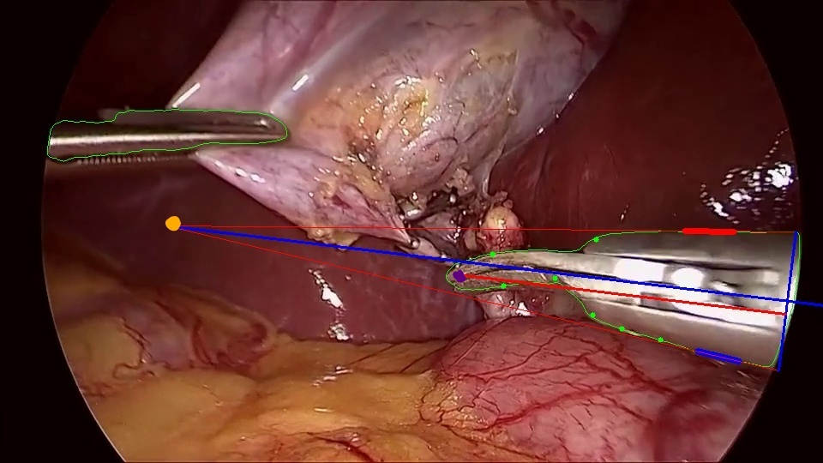

**Function** find_angle_bisector (…)

# This function is used to calculate the intersection of two identified straight tool edges

# Get the slope for the longest blue line and coordinates of the orange point

**Return** intersection coordinates, gradient of angle bisector of the intersection angle

**Function** get_symmetric_point (…)

# This function is used to get the width of the tool from one edge point and the angle bisector

# Get the vertical blue line

**Return** width_point1 coordinates, width_point2 coordinates

**Function** get_feature_points (…)

# This function is used to get the two identified straight tool edges

# Get the shortest red and blue lines

**Return** tool_edge1, tool_edge2

**Function** get_length (…)

# The red line starts from the purple point

**Return** length of the tool in the view

**Function** prep_for_Kmeans (…)

# This function is used to collect contour points for Kmeans algorithm

**Function** kmeans_algorithm (…)

# Apply kmeans algorithm to reduce massive contour points to only few points on the contour. Connecting some of them could get the identified straight tool

# Get green points on the contour

if __name__ == "__main__":

**For** each frame **do**

**If** have mass center on the right side

**If** the tool is located at the right bottom conner:

get_feature_points (…)

find_angle_bisector (…)

get_symmetric_point (…)

get_length (…)

**else if** the tool is inserted from the bottom (not contact with the curved edge):

get_feature_points (…)

find_angle_bisector (…)

get_symmetric_point (…)

get_length (…)

**else if** the tool is located at the right top conner:

get_feature_points (…)

find_angle_bisector (…)

get_symmetric_point (…)

get_length (…)

**else if** the tool is inserted from the top:

get_feature_points (…)

find_angle_bisector (…)

get_symmetric_point (…)

get_length (…)

**else** the tool is from the right side:

get_feature_points (…)

find_angle_bisector (…)

get_symmetric_point (…)

get_length (…)

**else:**

continue

record length and width for tools